Resume Builder

Student Reference Guide

# Overview

Naviance Student offers a Resume Builder to provide a framework for your resume development. You can use the Resume Builder to decide and work on different resume sections and then use the build tool to export the resume as a PDF or Word file. The Word file is a fully editable version of the resume.

# Accessing Resume Builder

You can access the Resume Builder in one of two ways:

* + From the *Naviance Student* Home page, navigate to About Me > Resume.

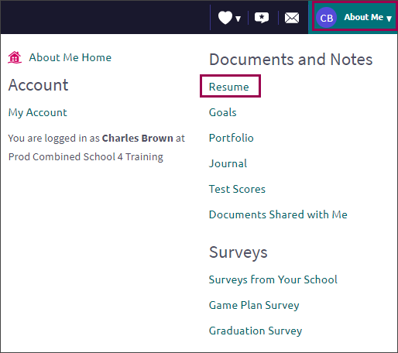

* + From the *About Me* Home page, choose Resume from the student banner.

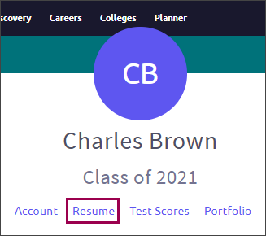

# Resume Sections

## What is Included?

Resume Sections are where you begin building the various sections of your resume. Use the Add Section button (+ sign) to choose the sections that you want to add.

Although there are many resume sections available, the most common are:

|  |  |  |
| --- | --- | --- |
| * + Objective | * + Education | * + Awards |
| * + Summary | * + Extracurricular Activities | * + References |
| * + Work Experience |  |  |

## Adding Sections

The steps to create a section are:

1. From Resume > Add/Update Sections, click Add Section (+ sign).
2. Choose the section to include on the resume.
   * The section heading will provide a tip to assist you with understanding the purpose of that section. If the tip is long, use More tips to expand the tip.
   * Each section provides related fields of data to complete. Enter the information as needed.
3. Use ADD to complete and add the section to the resume.
4. After adding an item, a new option displays to Add new information for that section.
   * EXAMPLE: if you have had multiple jobs, use Add New Work Experience after entering your first job in the Work Experience Section to input your second job.
5. Use the Edit and Remove options in each section as needed.

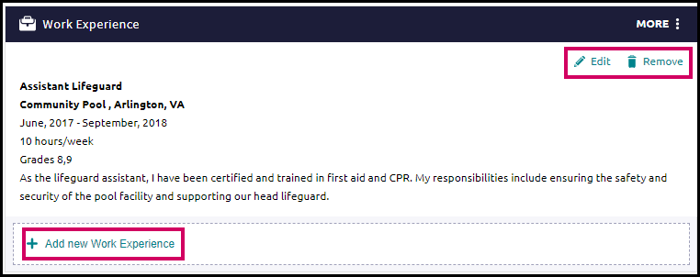

# Build the Resume

All the hard work is done, and the sections are complete! Now, it is time to build your resume.

## Getting Started

1. From the Resume page, click the Print/Export Resume tab.
2. Click the Add button (+).

The Add/Edit Saved Resume Step 1 displays – Set up Resume.

1. Enter a name for the resume in the Name your resume field.

### **NOTE**: The resume name will not display anywhere on your resume. It is for reference purposes only.

1. Select a template from Choose a print friendly template.
2. Click Continue.

Step 2, Choose Sections, displays.

1. From this step, use the checkboxes to turn on or off sections for this resume.

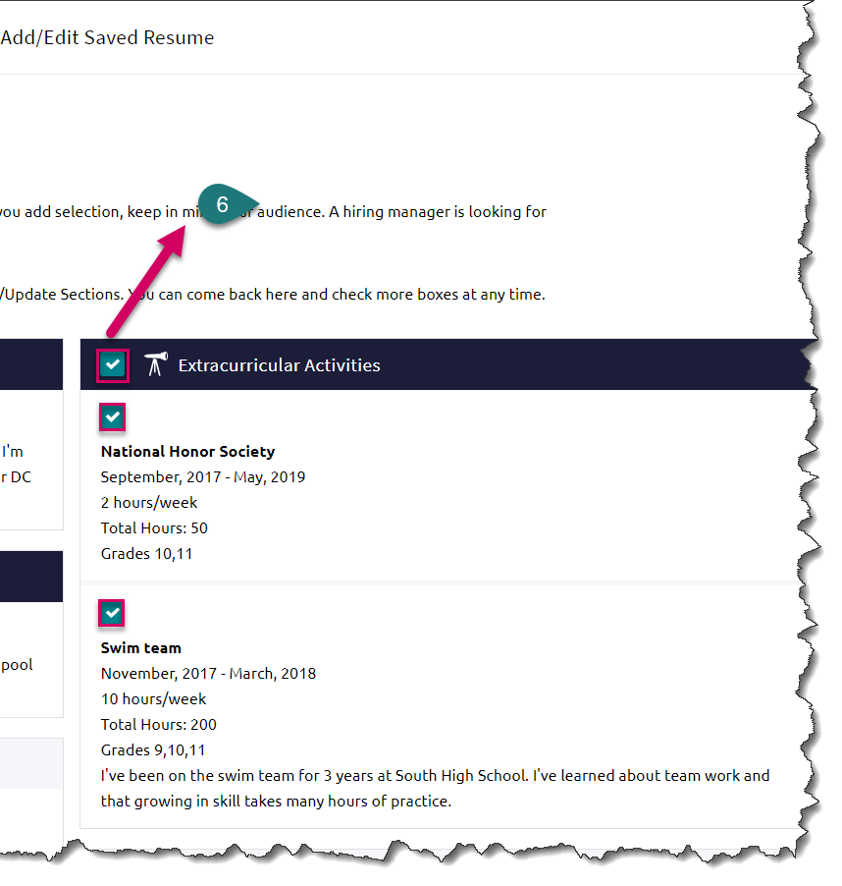

### **NOTE**: You can control which section and section entries you include on your resume. Just click the corresponding checkbox to add or remove sections or section entries.

1. Click Save Resume.

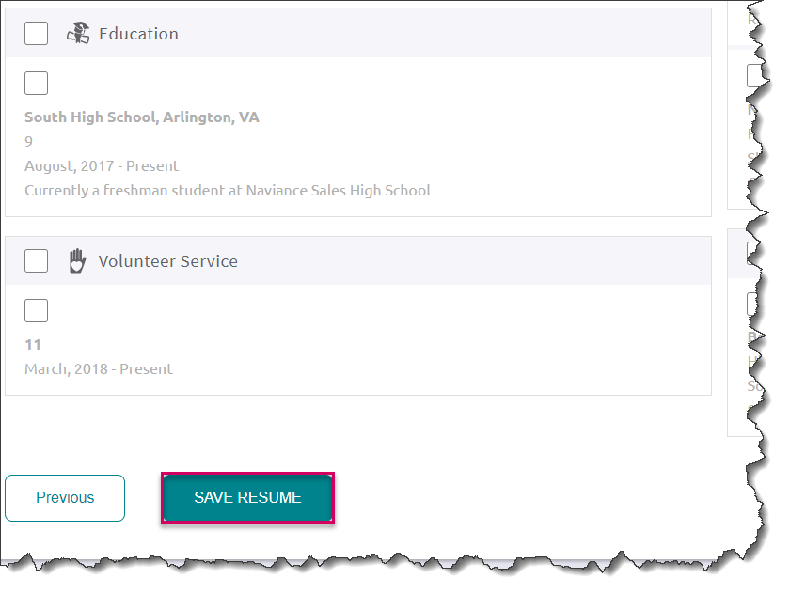

Your resume will be listed in My Saved Resumes.

1. Use Download PDF or Download DOCX options below the saved resume of choice to download that resume format.

### REMINDER: If you choose the DOCS format, you can edit it in Word.

1. Use Edit to make changes to the name or template assigned to your saved resume. Use Remove to delete the saved resume.

